Lab practice-6

N.vighneshwar reddy

192211784

1. Develop a system using UML for Personal Loan Management System. The admin should add new customersand view the customer's records. The admin should check the defaulters. Thecustomer can see his/her accountdetail and apply for a new loan by providingthe required documents, andpayslip. The admin should verify the document submitted and approvethe loan after verifying the payback potential of the customer.

USE CASE DIAGRAM

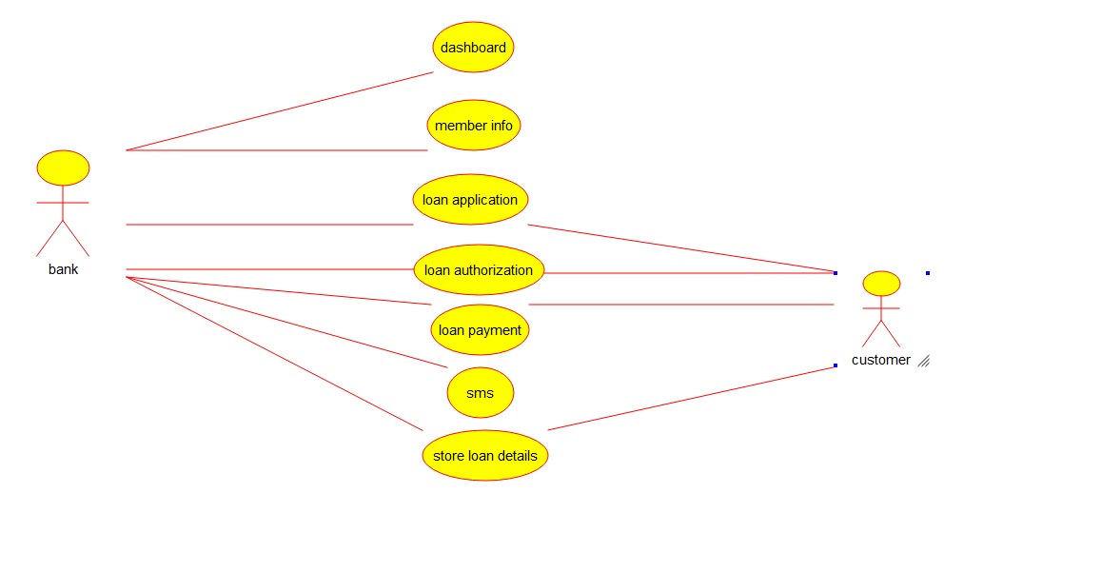

CLASS DIAGRAM

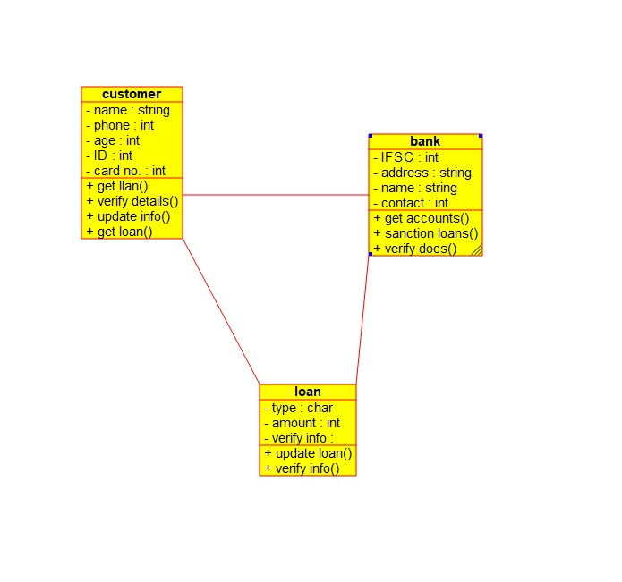

STATE DIAGRAM

